Hardware Overview

Input output devices – how the computer receives and sends information to the physical world. Screens, mouse, keyboard

CPU - Central Processing Unit: Runs the Program – always wonders “what to do next.” Doesn’t have intelligence, but is very fast

Input Devices- keyboard mouse touch screen

Output Devices: Screen, speakers, printer, dvd burner

RAM - Main Memory: fast small temporary storage, lost on reboot

Disk Drive/Memory stick – Secondary memory, slower large permanent storage, lasts until deleted

**Programming**

Command Prompt :

Dir- list folders and files

Cd (folder name): change to a new folder

**Reserved Words**

Python Scripts: interactive python is good for experiments and programs of 3-4 lines long, most programs are longer, so they are typed into a file and python is told to run the commands in the file, this is giving python a script, as a convention, we add .py as the suffix on the end of the file to indicate they contain python

**Interactive VS Script**

**Interactive** – you type directly into Python one line at a time and it responds

**Script –** you enter a sequence of statements/lines into a file using a text editor and tell python to execute the statements in the file;

**Program Steps/Flow –** a program is a sequence of steps that are conducted in order, some steps are conditional and can be skipped, sometimes a step or group of steps must be repeated, steps can be stored and used repeatedly as needed throughout various places in a program

**Variable –** named place in the memory where a programmer can store data and later retrieve the data using the given name of the variable, variable values can be changed in a later statement, the name must start with a letter or underscore, must consist of only letters numbers and underscores, is case sensitive,

**Assignment Statements –** We assign a value to a variable using the assignment statement (**=**), an assignment statement consists of a variable and an expression located on the right hand side

Conditional Statements -if statement

Else and if – elif – falls after if on the next line, continues the code, can have multiple, does not need to end with an else statement

Try/except -surround a dangerous section of code that may not work with try and except, if the code works except is skipped, if the code fails the program carries out the except function not causing a traceback(try this, if it doesn’t work do this)

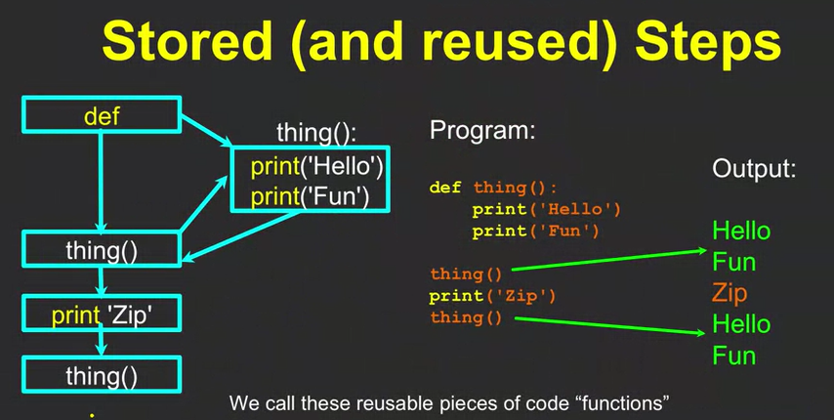Using Functions

Store and reuse - allows you to call on the same portion of code multiple times; like a variable only youre storing code; reserved words are built in functions, variable naming rules apply,

Storing Functions -

